Jan Swasthya Abhityan
National Convention
December 11-12, 2025, New Delhi

Health Financing Thematic Session
Concept Note

India’s health system is ailing today. The health workers face difficult work conditions and less remuneration. The frontline health workers are still fighting for minimum wages and decent working conditions. The shortage of human resources for health is widespread across States. The health infrastructure is dilapidated in many States and people at large are struggling to reach well-functioning health centres. Medicines are priced exorbitantly and many are out of reach of people due to high prices.

After the harrowing experience during the COVID-19 pandemic, people expected that the government will realise the need for strengthening the public health system and invest in it. However, what we witness since then is a general decline in public spending on health, a neglect of primary healthcare, and a renewed push towards privatising the health sector with the recent spree of privatisation of district hospitals across various states.
One of the necessary conditions for ensuring a robust health system is adequate allocation of public resources for the system. However, the public health spending in India is among the lowest in the world, while out of pocket spending remains unacceptably high. The public health expenditure has been consistently low for years, hovering around the 1.1% of GDP. The bulk of the total sending on health comes out of the pockets of the people.
Figure 1: Government Health Budget Expenditure as proportion of Total Government Expenditure

There is also the increasing emphasis on government funded health insurance schemes (GFHISs) such as the Pradhan Mantri Jan Arogya Yojana (PMJAY), which essentially operate by subsiding the private sector.
A look at the data for hospital admissions in the private sector under PMJAY from the start of the scheme in September 2018 shows that for the marginalised communities only a miniscule fraction of the total admissions were in the private sector. Of the poor Dalits who comprise 19.7% of total poor eligible for PMJAY, only 4% got admitted to private hospitals. Similarly, of the poor Tribal, who comprise 15.4% of the total poor eligible for PMJAY, only 1.6% got admitted to private hospitals.

Figure 2: Share of Poor Dalit and Tribal in Private Hospital Admissions under PMJAY vis-à-vis Share in Poor Eligible Population (%)

The GFHISs are also pushing people towards tertiarisation of healthcare and hence leading to escalation of costs. With greater complexity and hence wider information asymmetry, it becomes a fertile ground for exertion of monopoly power of the healthcare providers. Care that can be provided at a low resource setting by the general practitioner, gets pushed to a specialist. Conditions that can be treated with medication or simpler interventions get diverted towards complex surgical procedures. People who need only day-care service get induced towards hospital stays.
The avowed argument that is given in favour of GFHIs is that these would curb catastrophic health expenditure incurred by the people. However, the evidence showed that in India they have not been able to fulfil this. If GFHIs were effective in bringing down OOPE, per hospitalization expenses for those covered under these schemes should have also been reduced. As per NSS 75th Round data, per episode hospitalisation expenses have increased, particularly for the private sector, rather than declining (Indranil 2023). NSS CES round 2022-23 also substantiate the findings of other studies that those with GFHI cards are incurring higher expenditure compared to those using the cards. Moreover, GFHIs remain most effective in controlling OOP in public facilities in both rural and urban areas. Expenses incurred while using public facilities and card have much higher levels of per capita OOP, compared to those go to public facilities (fig 3).
Figure 3: Average per capita OOP (INR) among beneficiaries of GFHIs compared to non-beneficiaries

This state of affairs being promoted by the Government – starving the public health system and promoting the private sector – fits well in the overall neoliberal agenda of capitalism. The consequences of this agenda are in front of us - growing inequities in access, rising Out of pocket expenses (OOP), depleting public provisioning, growing organised market for healthcare.
One of the latest sources of OOP estimates is the Consumer Expenditure Survey (CES)-2022-23. CES 2022-23 data shows that OOP as a share of household consumption expenditure (HCE) is on a steady rise.
Figure 4: Share of Medical Expenditure in Household Consumption Expenditure (per cent)
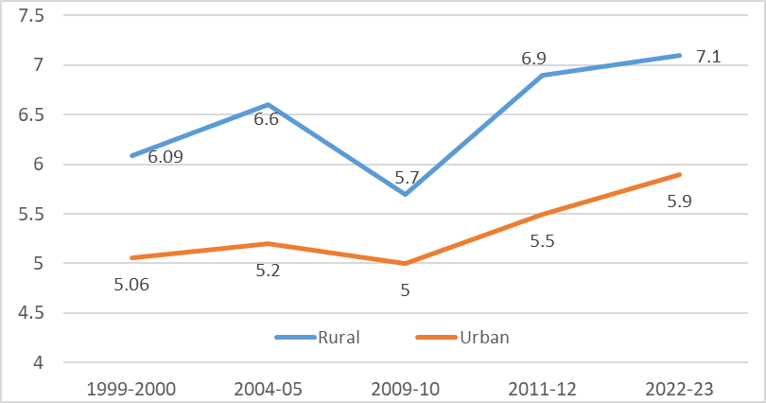
Source: Reports of NSS Consumer Expenditure Surveys, various rounds

Between 2011-12 and 2022-23 the share of OOPE in HCE has increased to 5.9 per cent from 5.5 per cent in urban areas and from 6.9 per cent to 7.1 per cent in rural areas (Fig 4). Increased proportion of the household budget going for health indicates that healthcare is becoming more expensive for households than the increase in their consumption expenditure.
Within India there are stark inequalities in terms of health expenditure by different state governments and the health outcomes achieved by various states. In some of the States such as Mizoram, Jammu & Kashmir, Sikkim, Goa, Delhi, Himachal, Puducherry a positive correlation between high public spending on health and better health services and outcomes.

Post COVID-19 while public spending on health by the Union Government has reduced, the overall share of health spending in States has increased. However, given competing priorities, not all States are able to spend on health adequately, resulting in inequalities in health expenditure across States. Moreover, with the introduction of Good and Services Tax (GST), the revenue envelope for the States has shrunk. In these circumstances, the Finance Commission needs to be step in and allocate funds to the States.

Further, while the flagship programmes like the National Rural Health Mission (NRHM) in 2004-05 promoted a bottom-up approach in planning and implementation of health policies, the system is overwhelmingly top-down. The policies are being designed at the Union level without regard to the needs of the people, of which PMJAY is a prime example. There are other implementation issues at the State and sub-State levels such as delays in funds disbursal, unspent funds and ineffective utilisation.

Some of the long-standing demands of Jan Swasthya Abhiyan are have been -

- Increase public expenditure on healthcare to reach 3.5% of GDP, with at least 1% of GDP being spent by the Union Government. States should get special financial envelopes for raised health expenditure.
Overall public health expenditure must be majorly increased to reach 3.5% in the short term. While enabling this, the Union government should transfer a much larger share of resources to states through the Finance Commission (FC), and a special financial envelope for states should be created for implementation of Right to Health and Healthcare under the XVI Finance Commission. Special grants under XV FC to local bodies should be augmented further, to foster decentralised governance and delivery of healthcare services. Allocation towards the National Health Mission should be enhanced to facilitate upgradation and expansion of rural and urban health services, and dealing with communicable as well as non-communicable diseases and climate related health challenges. Greater flexibility should be accorded to states to decide on the priorities within NHM and the process of participatory, decentralised planning should be strengthened.

- No one should face financial hardship due to Out-of-Pocket (OOP) Spending on health - Out-of-pocket expenditure on health must be minimised and brought down to below 25% of health spending in next five years
Out-of-pocket (OOP) spending on healthcare should be minimised so that no one is pushed into poverty, or faces catastrophic health spending and indebtedness due to healthcare expenses. Current decline in utilisation of health services due to high spending by households is unacceptable and must be reversed to ensure that no one has to forgo healthcare due to unaffordable costs. The objective of reducing OOP to less than 25% of health spending should be adopted as a national goal.

- Healthcare is primarily the government’s responsibility - Phase out Government-funded health insurance schemes such as PMJAY and Public Private Partnerships, replaced with a Public centred system for Universal Health Care
Phase out the Pradhan Mantri Jan Arogya Yojana - based on the discredited insurance model - in a phased manner, and replace this with a Public centred system for Universal Health Care. In the interim, all admissions under the scheme in private facilities must be based on gatekeeping by public health facilities, regarding those conditions where services are not available within the public system. There is clear need as well as potential to develop a public centred system for Universal Health Care, based on major expansion and strengthening of public services, while engaging regulated private providers to address current gaps. This system will provide ready access to quality healthcare, which will be available free of charge to everyone. Eliminate existing PPPs which weaken public services, abolish privatization of government health services, no government hospitals or services should be handed over to private companies.

